**LAB#10**

**OBJECT: Implement the circuit of full adder.**

**Sum = (A⊕B) ⊕C**

**Carry = AB + C(A⊕B)**

**APPARATUS:**

* 74LS08
* 74LS86
* 74LS32
* Bread Board
* Connecting Wires
* LED
* DC Supply

**SYMBOLS:**

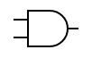

AND GATE

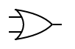

OR GATE

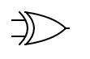

XOR GATE

**TRUTH TABLE:**

|  |  |  |  |  |
| --- | --- | --- | --- | --- |
| **A** | **B** | **C** | **SUM = (A⊕B) ⊕C** | **Carry =**  **AB + C(A⊕B)** |
| 0 | 0 | 0 | 0 | 0 |
| 0 | 0 | 1 | 1 | 0 |
| 0 | 1 | 0 | 1 | 0 |
| 0 | 1 | 1 | 0 | 1 |
| 1 | 0 | 0 | 1 | 0 |
| 1 | 0 | 1 | 0 | 1 |
| 1 | 1 | 0 | 0 | 1 |
| 1 | 1 | 1 | 1 | 1 |

**CIRCUIT DESIGN:**

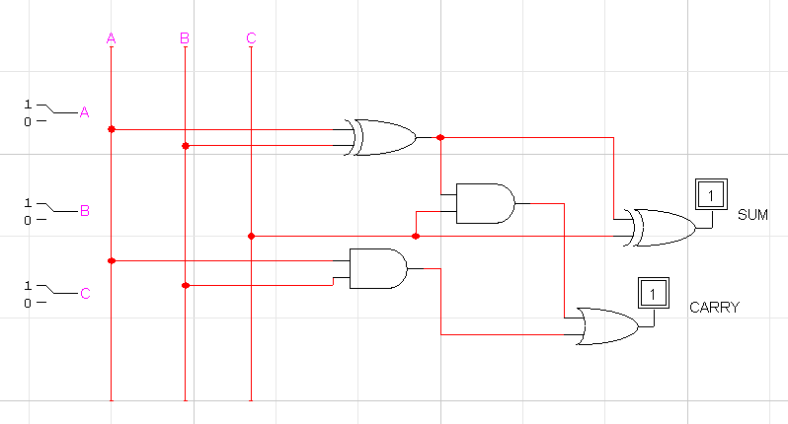

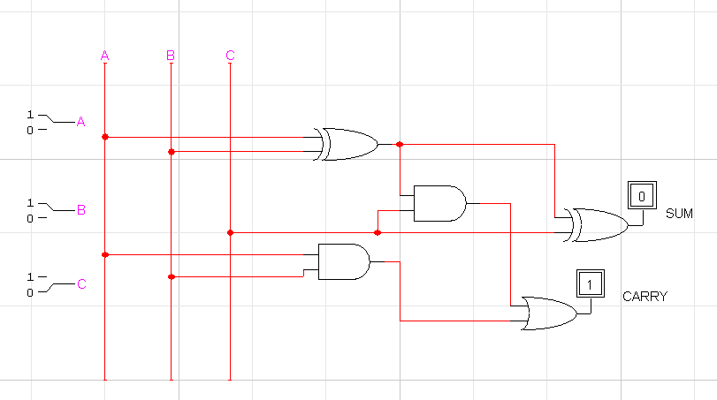

**CONCLUSION:**

The circuit is working according to the truth table.